Evidence of Tool Usage
Group 05
November 20, 2025

Tool | Evidence(Image)
Document, source code, and team man -agement :GitHub | 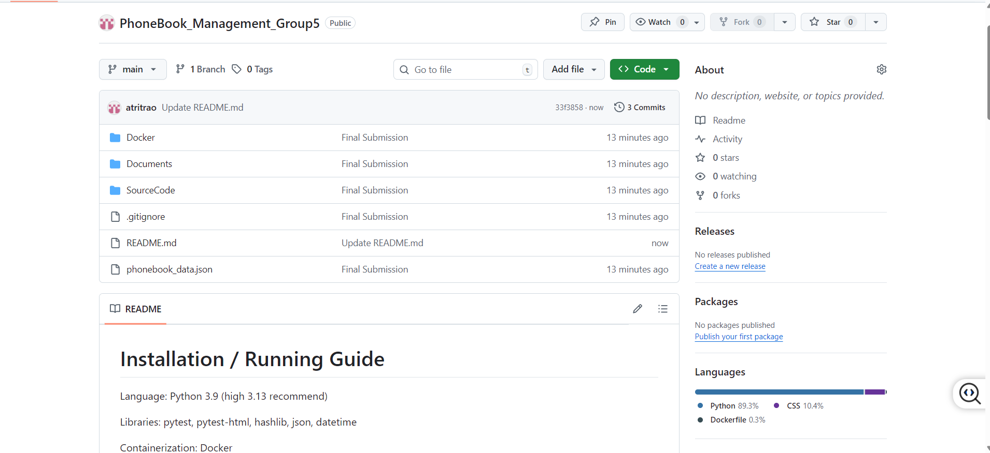
Programming IDEs: VSCode | 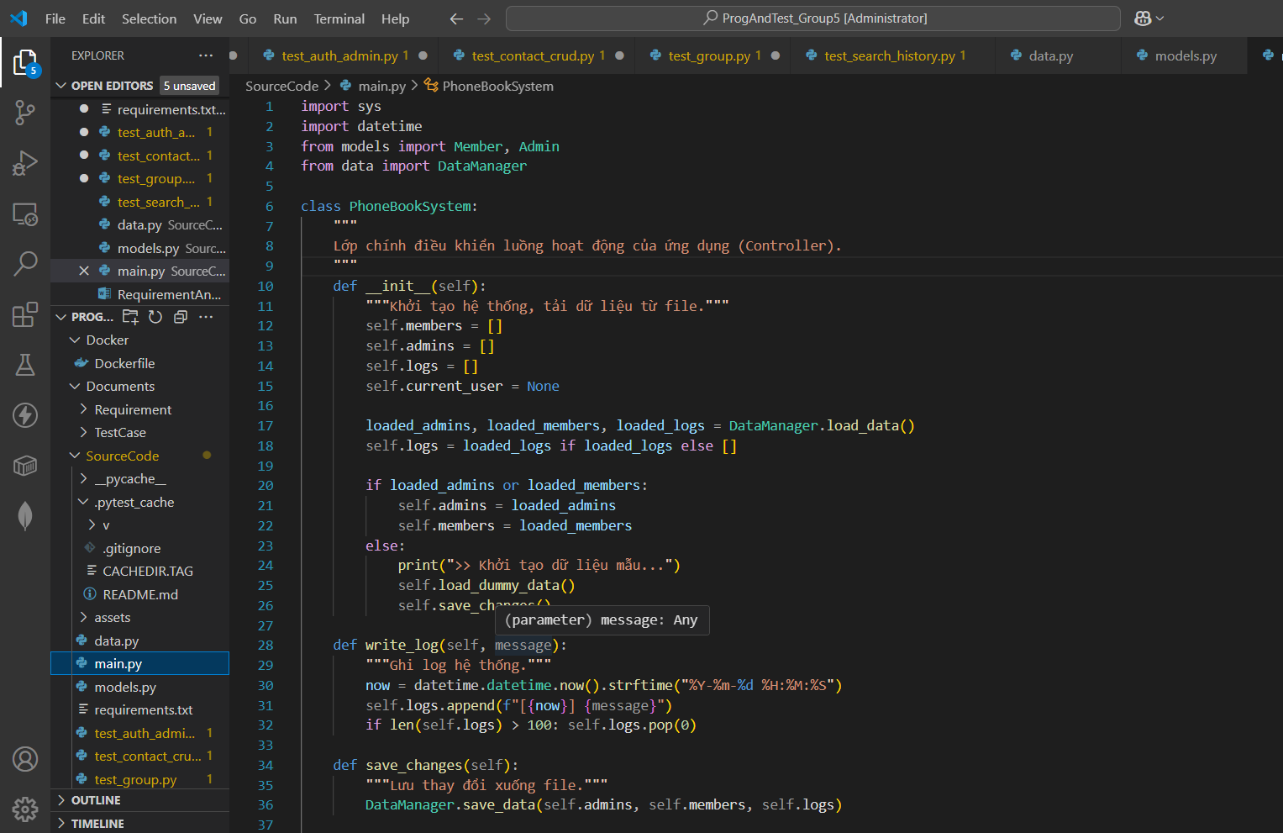
Creating test cases: GGsheet | 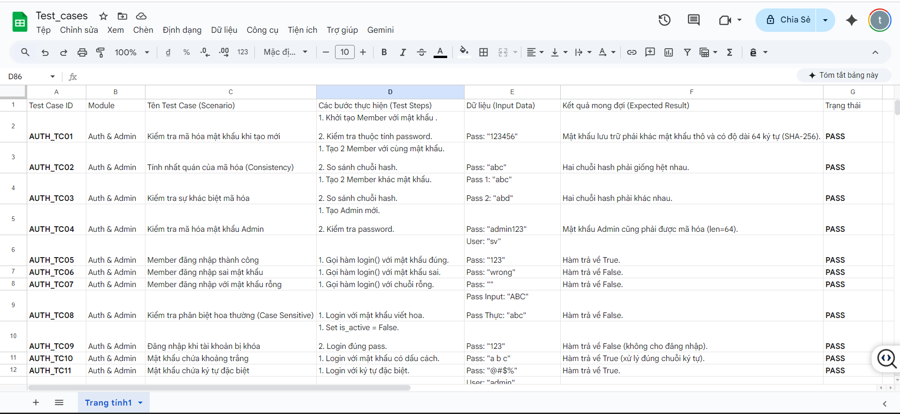
Unit testing tools: pytest | 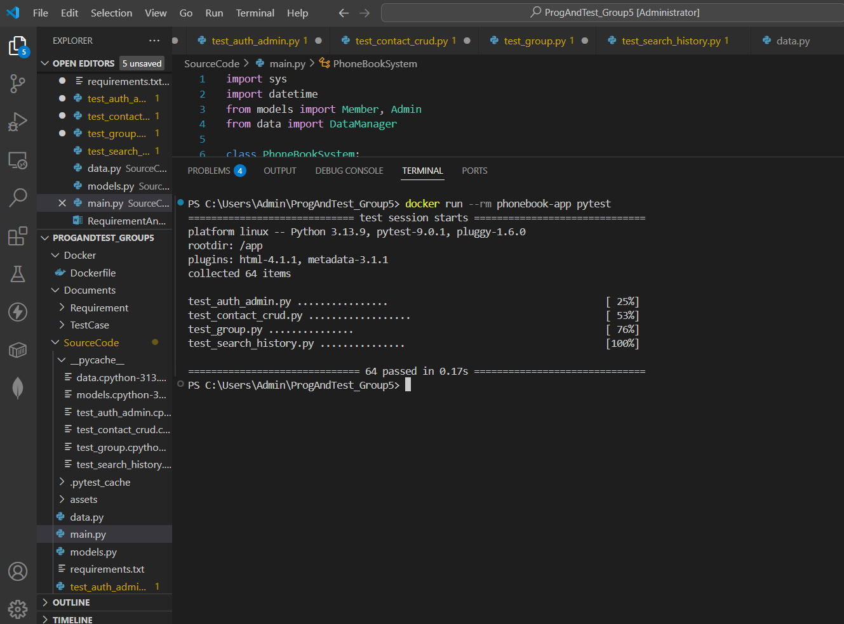
Packaginganddeploy ment:Docker | 